Our Redeemer Lutheran Church
Bryant, South Dakota
February-March 2024

Service Schedule Reminders
February
Ushers: Tim Steffensen, Jon Anderson
Altar Guild: Ronda Laube

March
Ushers: Brad Jacobson, Larry Warne
Altar Guild: Ronda Laube

April
Ushers: Al Kruse, Ron Welton, Wayne Weelborg
Altar Guild: Tracey Larson

Upcoming Events
February 9 – Bryant Up and Coming Community Event. Meal begins at 5:30 PM, Live Auction begins at 7:30 PM.

February 14 – Ash Wednesday – Soup Supper begins serving at 6:00 PM, service begins at 7:00 PM. Please see worship schedule included in this newsletter.

February 25 – Sharing Our History, hosted by Pastor Dave. Join us after worship for time to share how we came to be Our Redeemer. Potluck to follow.

March 16 – National Quilt Day – thank you to the Our Redeemer Quilters for the work you do!
**if you are interested in seeing what this group is up to, they meet every Wednesday at the church, 1:00 – 3:00 PM. Contact Jayne Jensen or Sharon Carstensen for more information.

March 31 is the deadline for designating your Thrivent Choice Dollars. Please consider Our Redeemer Lutheran Church when directing those funds.

Thank you for submitting your favorite hymns! We have 44 so far and are still taking suggestions! The list will be used in the worship planning so watch for your favorites in upcoming services.

Our Facebook page is live! Please like and share Our Redeemer Lutheran Church – the logo above is our also our Facebook profile picture.

Our website is coming soon - watch Facebook and your bulletin for updates!

Lenten Journey: Beyond Question
2024 Midweek Lenten Meditation based on a book by Eric Burtness

“Throughout the Gospels, Jesus uses questions to change the lives and deepen the discipleship of those who follow him. In this season you are invited to open Scripture and encounter Jesus and his transformative questions”
Eric Burtness, Book of Faith Lenten Journey: Beyond Question

When: Each of the Wednesdays in Lent beginning Ash Wednesday and continuing through Maundy Thursday and Good Friday.

Wednesday 6:00 to 6:45 pm
A simple meal of soup and bread served in the fellowship hall.

Wednesday 7:00 to 7:30 pm
Lenten worship in the sanctuary with hymns, scripture, prayer, and original meditations by Pastor Dave and Pam.

What and where:
February 14: Ash Wednesday, at both Good Hope & Our Redeemer
What are you looking for?
Ash Wednesday Worship with imposition of ashes, meditation, and Holy Communion

February 21: Midweek Joint Lenten Worship at Good Hope
Where is your faith?

February 28: Midweek Joint Lenten Worship at Our Redeemer
Who do you say that I am?

March 6: Midweek Joint Lenten Worship at Good Hope
What do you want me to do for you?

March 13: Midweek Joint Lenten Worship at Our Redeemer
Do you love me?

March 20: Midweek Joint Lenten Worship at Good Hope
How will you believe what I say?

March 28: Maundy Thursday Worship at both Good Hope & Our Redeemer
Do you know what I have done for you?
Maundy Thursday with Holy Communion and the stripping of the altar.

March 29: Good Friday Worship at both Good Hope & Our Redeemer
My God, my God, why have you forsaken me?
Good Friday Tenebrae worship with the extinguishing of candles and gathering darkness

Let us give thanks…
For our food, we rejoice.
For our friends, we rejoice.
For every season, we rejoice.
For every good gift, we rejoice.
Thank you, O God, for our church, and continue to bless us with your presence.
Thank you, O God, for our community, and keep us safe.
In Jesus name we pray, Amen.

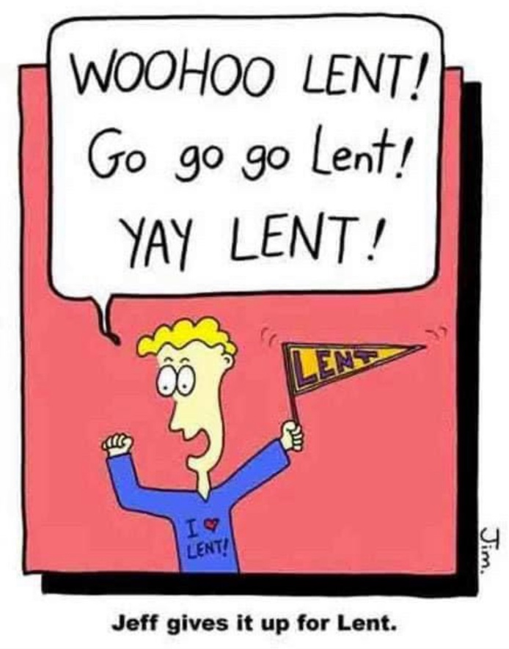

Our Redeemer Lutheran Church
PO Box 115
Bryant, SD 57221

